

**HUMAN BIOLOGY**

**UNIT 3**

**MARKING GUIDE**

***TIME ALLOWED FOR THIS PAPER***

Reading time before commencing work: Ten minutes

Working time for the paper: Three hours

***MATERIALS REQUIRED/RECOMMENDED FOR THIS PAPER***

**To be provided by the supervisor:**

* This Question/Answer Booklet; Formula and Constants sheet

**To be provided by the candidate:**

* Standard items: pens, pencils, eraser or correction fluid, ruler, highlighter.
* Special items: Calculators satisfying the conditions set by the SCSA for this subject.

***IMPORTANT NOTE TO CANDIDATES***

No other items may be taken into the examination room. It is **your** responsibility to ensure that you do not have any unauthorised notes or other items of a non-personal nature in the examination room. If you have any unauthorised material with you, hand it to the supervisor **before** reading any further.

**Structure of this paper**

|  |  |  |  |  |  |
| --- | --- | --- | --- | --- | --- |
| Section | Number of questions available | Number of questions to be answered | Suggested working time  (minutes) | Marks available | Percentage of exam |
| Section One  Multiple-choice | 30 | 30 | 40 | 30 | 30 |
| Section Two  Short Answer | 7 | 7 | 90 | 100 | 50 |
| Section Three:  Extended Answer | 2 | 1 | 50 | 40 | 20 |
| 2 | 1 |
|  |  |  |  | **Total** | 100 |

**Instructions to candidates**

1. The rules for the conduct of Western Australian external examinations are detailed in the *Year 12 Information Handbook 2022.* Sitting this examination implies that you agree to abide by these rules.
2. Write your answers in this Question/Answer Booklet.
3. When calculating numerical answers, show your working or reasoning clearly. Give final answers to **three** significant figures and include appropriate units where applicable.

When estimating numerical answers, show your working or reasoning clearly. Give final answers to a maximum of **two** significant figures and include appropriate units where applicable.

1. You must be careful to confine your responses to the specific questions asked and follow any instructions that are specific to a particular question.
2. Spare pages are included at the end of this booklet. They can be used for planning your responses and/or as additional space if required to continue an answer.
   * Planning: If you use the spare pages for planning, indicate this clearly.
   * Continuing an answer: If you need to use the space to continue an answer, indicate in the original answer space where the answer is continued, i.e. give the page number. Refer to the question(s) where you are continuing your work.

# **Section One: Multiple-choice 30% (30 marks)**

This section has **30** questions. Answer all questions on the separate Multiple-choice answer sheet provided. For each question shade the box to indicate your answer. Use only a blue or black pen to shade the boxes. Do not use erasable or gel pens. If you make a mistake, place a cross through that square, then shade your new answer. Do not erase or use correction fluid/tape. Marks will not be deducted for incorrect answers. No marks will be given if more than one answer is completed for any question.

Suggested working time for this section is 40 minutes.

1. The role of helper T cells is to
   1. destroy cells that are infected with bacteria.
   2. control the adaptive immune response.
   3. generate antibodies.
   4. engulf parasites.
2. Which of the following is a feature common to both T cells and B cells?
   1. Creating memory cells
   2. Rapidly responding to pathogens after the first exposure
   3. Being able to physically attach to pathogens
   4. Being able to travel through the bloodstream
3. Negative feedback occurs when
   1. the initial stimuli is reinforced.
   2. the initial stimuli is maintained.
   3. the initial stimuli is reversed.
   4. the initial stimuli is stopped.
4. Which of the following is an **incorrect** comparison between the autonomic and somatic nervous systems?
   1. The autonomic NS is involuntary, and the somatic NS is voluntary.
   2. The effectors of the autonomic NS are smooth muscles, the effectors of the somatic NS are skeletal muscles.
   3. Acetylcholine has an excitatory effect in the autonomic NS and an inhibitory effect in the somatic NS.
   4. The autonomic NS has motor pathways only whereas the somatic NS has sensory and motor pathways.

Questions 5 and 6 refer to the statement below.

A researcher was attempting to determine the impact of the sweating response when different concentrations of adrenaline were administered to allergy sufferers having an allergic reaction.

1. What was the independent variable of this experiment?
   1. Sweating response
   2. Administered adrenaline
   3. Allergic reaction
   4. Allergy suffering individuals
2. What was the dependent variable of this experiment?
   1. Sweating response
   2. Administered adrenaline
   3. Allergic reaction
   4. Allergy suffering individuals
3. Which of the following is a behavioural response to **increased** body temperature?
   1. Increased sweating
   2. Splashing cold water on your face
   3. Putting on a jumper
   4. Vasodilation
4. The endocrine organ that produces the hormone calcitonin is the
   1. thyroid gland.
   2. parathyroid gland.
   3. adrenal medulla.
   4. adrenal cortex.
5. Which of the following comparisons of type I and II diabetes is **incorrect**?
   1. Type I diabetes occurs earlier in life and type II diabetes occurs later in life.
   2. Type I diabetes can be caused by autoimmune issues and type II is can be caused by lifestyle.
   3. Both type I and II diabetes require insulin injections.
   4. Both type I and II diabetes require careful monitoring of diet.
6. A hypothesis may be accepted by the scientific community if the
   1. the sample size tested is over 20% of the population.
   2. the data collected shows a difference between the experimental and control.
   3. the data collected supports the hypothesis.
   4. other researchers peer-review and obtain similar results.
7. The clear liquid which fills the space between the membranes of the brain is
   1. plasma.
   2. lymph.
   3. cerebrospinal fluid.
   4. intracellular fluid.
8. Stimulation of the parasympathetic nervous system would cause
   1. heart rate to increase.
   2. dilation of the pupils.
   3. stimulation of the digestive system.
   4. decreased sweat production.

Question 13-15 refers to the diagram below.

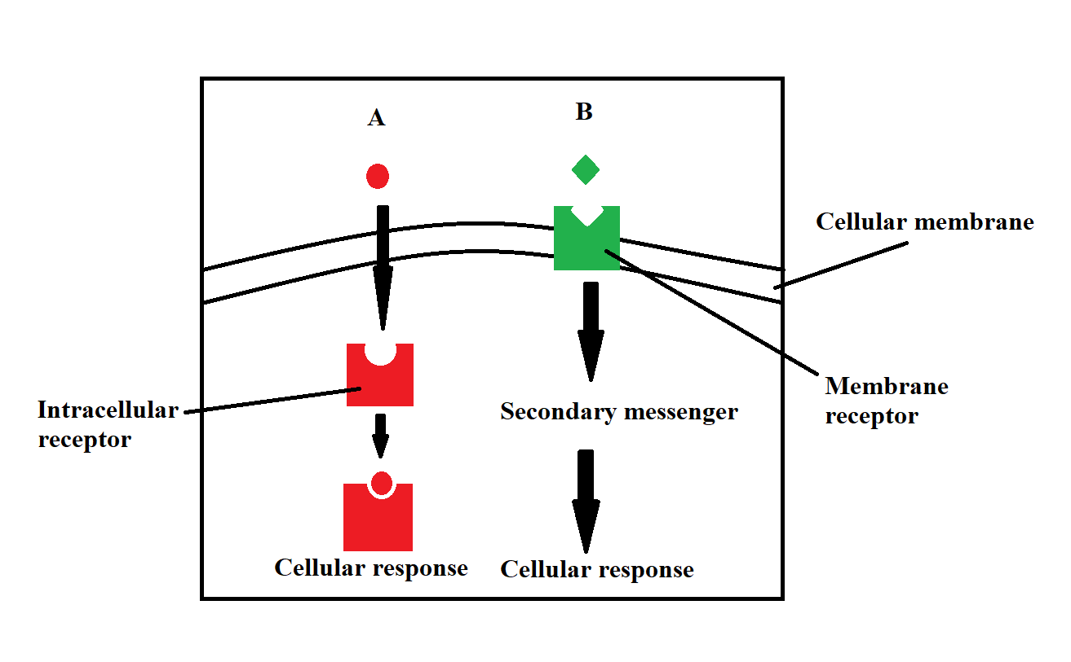

1. Which of the following show the correct names of the hormones shown above?
   1. A is a lipid soluble hormone and B is a water-soluble hormone.
   2. B is a lipid soluble hormone and A is a water-soluble hormone.
   3. A and B are both lipid soluble hormones.
   4. A and B are both water soluble hormones.
2. Which of the following is a correct description of speed of hormonal action?
   1. Water-soluble and lipid soluble hormones both have a rapid action
   2. The speed of action is not determined by hormone type
   3. Water-soluble hormones have a more rapid action than lipid soluble hormones
   4. Lipid soluble hormones have a more rapid action than water-soluble hormones
3. Which of the following is a correct description of the duration of hormonal action?
   1. Water-soluble and lipid soluble hormones both have a long duration
   2. The duration is not determined by hormone type
   3. Water-soluble hormones have a longer duration than lipid soluble hormones
   4. Lipid soluble hormones have a longer duration than water-soluble hormones
4. In nervous transmission, how is the impulse propagated along the fibre?
   1. Diffusion
   2. Exocytosis
   3. Osmosis
   4. Facilitated diffusion
5. Some human cells produce cytokines. A major function of cytokines is
   1. signalling immune cells in inflammatory response.
   2. stimulating B cells to directly attack virally infected cells.
   3. diffusing across the synaptic gap to stimulate adjacent cells.
   4. communicating with distant cytokine producing cells.
6. Which of the following pairings is **incorrect**?
   1. hormone: luteinising hormone; target organ: testes
   2. hormone: antidiuretic hormone; target organ: kidney
   3. hormone: oxytocin; target organ: ovary
   4. hormone: thyroid stimulating hormone; target organ: thyroid
7. What immediate effect would the removal of the pancreas have on the composition on the persons urine?
   1. Amino acids appear in the urine
   2. Glucose appears in the urine
   3. The urine contains more creatine
   4. The urine contains a greater concentration of salts
8. A drastic underproduction of antidiuretic hormone could result in
   1. Reduced thirst.
   2. retention of water in the body.
   3. increased urine concentration.
   4. excessive urine production.

Use the diagram below to answer questions 21-23

1. Which label shows the neurotransmitter released into the synapse?
   1. A
   2. B
   3. C
   4. D
2. What is the function of D?
   1. Breaks down the neurotransmitter after it is released from the receptor
   2. Breaks down the neurotransmitter to stop it from attaching to the receptor
   3. Breaks down the neurotransmitter if there are too many in the synapse
   4. Breaks down the neurotransmitter and receptor protein
3. The release of neurotransmitters into the synapse is triggered by the influx of Ca2+ into the presynaptic cell. How does this Ca2+ impact transmission at the synapse?
   1. The Ca2+ stimulates neurotransmitter production
   2. The Ca2+ causes neurotransmitter to be packaged into vesicles.
   3. The Ca2+ causes neurotransmitter vesicles to migrate to the plasma membrane
   4. The Ca2+ causes neurotransmitter vesicles to empty into the synapse by exocytosis
4. The receptor that detects a need for an increase in breathing rate would be most sensitive to which of the following factors?
   1. Blood pressure
   2. Blood oxygen concentration
   3. Blood osmotic pressure
   4. Blood carbon dioxide concentration
5. The part of the brain most associated with the coordination of fine motor control is the
   1. medulla oblongata.
   2. cerebrum.
   3. cerebellum.
   4. hypothalamus.
6. Which is the best definition of “validity” according to the scientific method?
   1. baseline data to compare experiment results to
   2. the extent to which an experiment produces consistent results
   3. the extent to which a concept is correctly and precisely measured
   4. the extent to which the test measures what was intended

Use the table below to answer questions 27 and 28.

|  |  |
| --- | --- |
| **Disease** | **Pathogen** |
| Malaria | protozoa |
| Influenza | virus |
| Measles | virus |
| Bubonic Plague | bacteria |
| Ringworm | fungus |

1. Which of these diseases would be treated effectively with antibiotics?
   1. Malaria
   2. Measles
   3. Bubonic Plague
   4. Ringworm
2. What type of medication could be used to treat the symptoms of influenza?
   1. Bacteriostatic antibiotics
   2. Bactericidal antibiotics
   3. Anaesthetics
   4. Antivirals
3. Many experiments have an ‘experimental’ and a ‘control’ group. Which of the following statements regarding these two groups is correct?
   1. The control group is identical to the experimental group except for the independent variable
   2. The control group may have several differences between the experimental group
   3. The control group must be twice the size of the experimental group
   4. Participants are aware of which group they are in
4. A Human Biology student was investigating the impact of regular aerobic exercise on high school students’ ability to focus in class.

Which of the following variables would **NOT** need to be controlled to ensure valid results?

* 1. Sex of the participants
  2. Diet of the participants
  3. Hours of sleep for the participants
  4. Consistent measurement tool to determine focus

|  |  |
| --- | --- |
| Question | Answer |
| 1 | B |
| 2 | A |
| 3 | C |
| 4 | C |
| 5 | B |
| 6 | A |
| 7 | B |
| 8 | A |
| 9 | C |
| 10 | D |
| 11 | C |
| 12 | C |
| 13 | A |
| 14 | C |
| 15 | D |
| 16 | A |
| 17 | A |
| 18 | C |
| 19 | B |
| 20 | D |
| 21 | B |
| 22 | A |
| 23 | C |
| 24 | D |
| 25 | C |
| 26 | D |
| 27 | C |
| 28 | D |
| 29 | A |
| 30 | A |

# **Section Two: Short answer 50% (100 marks)**

This section has **seven** questions. Answer **all** questions. Write your answers in the spaces provided.

Supplementary pages for planning/continuing your answers to questions are provided at the end of this Question/Answer booklet. If you use these pages to continue an answer, indicate at the original answer where the answer is continued, i.e. give the page number.

Suggested working time for this section is 90 minutes.

**Question 31 (19 marks)**

Athletes training for sports with specific weight divisions like boxing and weightlifting participate in ‘cutting weight’ to be placed in the lowest weight category possible. One method used by these athletes is to dehydrate themselves before being weighed to cut as much water weight from their body as possible.

A long-term effect of dehydration is kidney damage. A researcher wants to investigate the possible long-term consequences on kidney function for athletes who practice ‘cutting weight’. The test that the researcher will use to determine kidney function is the Glomerular Filtration Rate (GFR).

1. Describe a control group that could be used for this study. (2 marks)

|  |  |
| --- | --- |
| Athletes | 1 mark |
| Who do not practise ‘cutting weight’ | 1 mark |

1. Suggest a method that the researcher could employ to test the hypothesis. ‘Athletes in their 20’s who practise ‘cutting weight’ have reduced kidney function as measured by the GFR compared to a control group’.

(5 marks)

|  |  |
| --- | --- |
| Select participants made up of athletes in their 20’s | 1 mark |
| Divide the group into an experimental and control group. | 1 mark |
| The experimental group is made up of athletes who cut weight and the control group is made up of athletes who do not cut weight. | 1 mark |
| Test the kidney function of both groups using GFR | 1 mark |
| Compare the kidney function of the two groups | 1 mark |

Other correct methods may be accepted

The test that the researcher will use to determine kidney function is the Glomerular Filtration Rate (GFR) the results of which are shown in the chart below.

1. Use the chart above to answer the following.

(3 marks)

1. What stage of chronic kidney disease would a person be at if their GFR result was 35?

|  |  |
| --- | --- |
| Stage 3b | 1 mark |

1. What percentage of kidney function would a person have if they were at stage 5 of chronic kidney disease?

|  |  |
| --- | --- |
| (less than) 15% | 1 mark |

1. What percentage of kidney function would a person have if their GFR result was 70?

|  |  |
| --- | --- |
| 70% | 1 mark |

The researcher found the following results.

|  |  |  |  |
| --- | --- | --- | --- |
| **Experimental Group** | **GFR** | **Control Group** | **GFR** |
| Participant 1 | 90 | Participant 1 | 97 |
| Participant 2 | 80 | Participant 2 | 95 |
| Participant 3 | 72 | Participant 3 | 92 |
| Participant 4 | 63 | Participant 4 | 88 |
| Participant 5 | 55 | Participant 5 | 73 |

1. Use the grid below to construct a line graph for the experimental and control groups.

(5 marks)

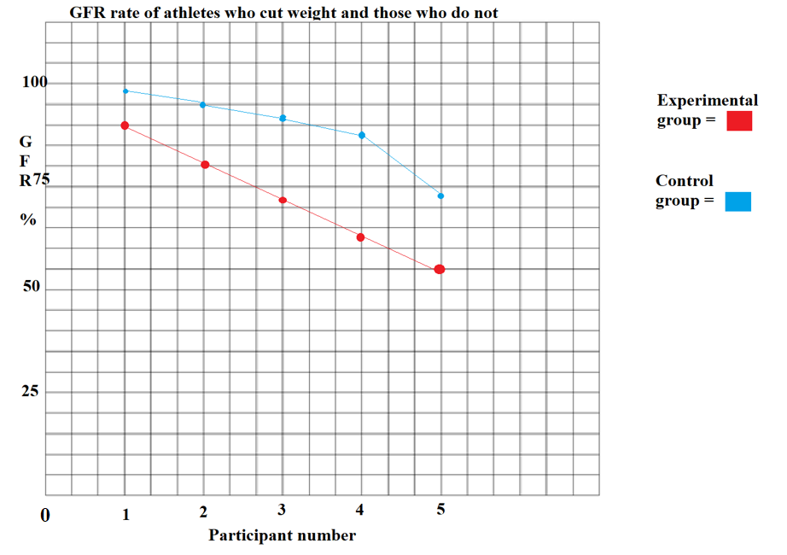

|  |  |
| --- | --- |
| Meaningful title | 1 mark |
| X axis label (1/2) and units (1/2) | 1 mark |
| Y axis label (1/2) and units (1/2) | 1 mark |
| Experimental group accurately labelled | 1 mark |
| Control group accurately labelled | 1 mark |

1. Determine the mean GFR for each group. (2 marks)

|  |  |
| --- | --- |
| Experimental: 72 | 1 mark |
| Control: 89 | 1 mark |

1. State a conclusion that could be made based on the results of this study*.* (2 marks)

|  |  |
| --- | --- |
| Cutting weight | 1 mark |
| Causes decreased GFR | 1 mark |

**Question 32 (12 marks)**

Synapse Australia’s Brain Injury Organisation is a non-profit organisation that supports people who suffer brain injuries. You are considering volunteering for this organisation. As part of the recruitment process, you need to demonstrate understanding of structures of the brain and implications of injuries to various sections.

1. Name the structures shown in the diagram above. (3 marks)

|  |  |
| --- | --- |
| A: Dura(mater) | 1 mark |
| B: Arachnoid | 1 mark |
| C: Pia(mater) | 1 mark |

1. Describe how the cerebrospinal fluid (CSF) and the cranium provide additional protection for the brain. (4 marks)

|  |  |
| --- | --- |
| CSF: Provides a fluid cushion/buffer | 1 mark |
| CSF: Acts as a shock absorber | 1 mark |
| Cranium: Defence against physical impact | 1 mark |
| Cranium: Protection/support | 1 mark |

1. There are many effects of traumatic brain injury. For each of the symptoms suggest a part of the brain most likely to have received the injury.

(5 marks)

|  |  |
| --- | --- |
| **Symptom** | **Part of the brain** |
| A loss of taste and smell | **Cerebrum/Parietal lobe** |
| Sleep disorders | **Hypothalamus** |
| Being able to initiate movement but having difficulty coordinating fine motor functions. | **Cerebellum** |
| Inability to breathe without a respirator. | **Medulla oblongata** |
| Extreme emotional outbursts. | **Cerebrum/ Frontal lobe/ Prefrontal cortex** |

**Question 33 (13 marks)**

Hormones are chemical messengers that cause changes in the body.

1. Describe how hormones are transported to target cells throughout the body. (3 marks)

|  |  |
| --- | --- |
| Hormones are released from endocrine organs into the blood stream | 1 mark |
| They travel in the bloodstream to all cells in the body | 1 mark |
| They attach to target cells that have receptor proteins on the surface/enter the cell through the membrane | 1 mark |

Some hormones occur in antagonistic pairs. This is when hormones have opposite effects on the body.

1. Complete the table below to identify the antagonistic hormones. (4 marks)

|  |  |
| --- | --- |
| **Hormone** | **Effect on the Body** |
| **Calcitonin** | Secreted when blood calcium is high to supress breakdown of the bone matrix. |
| **Parathyroid Hormone** | Secreted when blood calcium is low and increases calcium absorption in the intestines. |
| **Glucagon** | Secreted when blood glucose is low to cause glucose production from glycogen. |
| **Insulin** | Secreted when blood glucose is high to cause glycogen production from glucose. |

1. Growth hormone deficiency (GHD) is a disorder that is caused by the underproduction of growth hormone in the body.
2. Name the endocrine gland that produces growth hormone. (1 mark)

|  |  |
| --- | --- |
| Anterior Pituitary | 1 mark |

1. Describe **three (3)** functions of growth hormone on the body.

(3 marks)

|  |  |
| --- | --- |
| Stimulates bone growth | 1 mark |
| Stimulates muscle growth | 1 mark |
| Increased blood concentration of glucose/fatty acids | 1 mark |

1. Suggest **two (2)** symptoms a person may suffer because of the underproduction of growth hormone if they suffer with GHD.

(2 marks)

|  |  |
| --- | --- |
| Decreased bone density | 1 mark |
| Decreased muscle mass | 1 mark |
| Accept any other correct symptoms including increased fat mass, lack of stamina, fatigue etc | 1 mark |

**Question 34 (15 marks)**

Homeostasis is a series of processes in order to keep the human body within a narrow set of tolerance levels.

1. Describe the term ‘dynamic equilibrium’ as it applies to homeostasis.

(3 marks)

|  |  |
| --- | --- |
| As the body undergoes numerous internal changes | 1 mark |
| The homeostatic levels hover around an ideal set point | 1 mark |
| If levels increase, changes occur in the body to decrease levels (or vice versa) | 1 mark |

1. Complete the table below to show the missing homeostatic mechanism, modulator and receptors. (6 marks)

|  |  |  |
| --- | --- | --- |
| **Homeostatic Mechanism** | **Modulator** | **Receptor** |
| Thermoregulation | Hypothalamus | Thermoreceptors |
| Blood gas concentration | Medulla | Chemoreceptors |
| Blood glucose concentration | Islets of Langerhans in the Pancreas | Chemoreceptors |
| Blood water concentration | Hypothalamus | Osmoreceptors |

1. Describe the processes that the body goes through to maintain stable blood sugar levels in the blood if blood sugar levels decrease.

(6 marks)

|  |  |
| --- | --- |
| Stimulus: Blood sugar levels decrease | 1 mark |
| Receptor: Alpha cells of islets of Langerhans | 1 mark |
| Modulator: Alpha cells of islets of Langerhans secrete glucagon | 1 mark |
| Effector: Liver/ Body cells/skeletal muscle | 1 mark |
| Response: Increased gluconeogenesis/glycogenolysis | 1 mark |
| Feedback: Negative | 1 mark |

**Question 35 (15 marks)**

The diagram below shows the process of myelination of an axon

1. What is the name of the cell that creates the myelin sheath in the PNS? (1 mark)

|  |  |
| --- | --- |
| Schwann Cell | 1 mark |

Guillain-Barré syndrome (GBS) is a rare disorder where the body’s immune system damages the myelin sheath of neurons. The damage to the nerves causes muscle weakness and sometimes paralysis. While its cause is not fully understood, the syndrome often follows infection with a virus and is most often found in people over 50. The cells of the autonomic nervous system are affected which can cause heart-rate irregularities.

1. Identify **two (2)** functions of the myelin sheath. (2 marks)

|  |  |
| --- | --- |
| Speeds up nerve impulses | 1 mark |
| Insulates axon/protects axon/separates axon from external environment | 1 mark |

1. Explain how damage to the myelin sheath can cause muscle weakness and paralysis. (3 marks)

|  |  |
| --- | --- |
| Nerves that control movement are myelinated to ensure efficient transmission | 1 mark |
| Damage to the myelin sheath could slow down transmission causing muscle weakness | 1 mark |
| Damage to the myelin sheath could stop transmission causing paralysis | 1 mark |

1. Explain how damage to the autonomic nervous system can cause heart-rate irregularities. (3 marks)

|  |  |
| --- | --- |
| The autonomic nervous system contains sympathetic and parasympathetic pathways | 1 mark |
| Damage to the sympathetic pathway would prevent the heart from increasing heart rate/ vice versa/ damage to either pathway would stop the heart from responding to external stimuli | 1 mark |
| The lack of coordination of the sympathetic and parasympathetic pathways causes irregularity of heartbeat | 1 mark |

1. Compare and contrast how nervous propagation occurs along myelinated and unmyelinated axons. (6 marks)

|  |  |
| --- | --- |
| Myelinated axons propagate the impulse faster | 1 mark |
| Unmyelinated axons propagate the impulse slower | 1 mark |
| Myelinated axons skip impulse between Nodes of Ranvier/ use saltatory conduction | 1 mark |
| Unmyelinated axons have depolarisation occur at all points along the axon | 1 mark |
| Both conducts using an electrochemical impulse | 1 mark |
| Both can transmit inhibitory and excitatory messages | 1 mark |

Accept other correct answers

**Question 36 (15 marks)**

In 2021 three different vaccines were released to the Australian public to protect them from contracting the corona virus. They were AstraZeneca, Pfizer and Moderna. AstraZeneca was a vaccine that was made using a live attenuated viral vector while Pfizer and Moderna were both RNA vaccines.

1. Describe the features of live attenuated vaccines. (2 marks)

|  |  |
| --- | --- |
| Uses a living version of the pathogen | 1 mark |
| That has been altered to decrease virulence | 1 mark |

1. Name and describe **two (2**) other types of vaccines. (4 marks)

|  |  |
| --- | --- |
| Sub-unit/Conjugate | 1 mark |
| Sub-unit/Conjugate: Uses one part or section of a pathogen | 1 mark |
| Toxoid | 1 mark |
| Toxoid: Uses the inactivated toxin | 1 mark |
| Dead/Inactivated/Killed | 1 mark |
| Dead/Inactivated/Killed: Uses the pathogen that is dead | 1 mark |

Any two correct vaccine types with appropriate descriptions for 4 marks total

1. Explain how vaccines work to provide immunity against infection. (4 marks)

|  |  |
| --- | --- |
| The B-cells in the lymph nodes recognise the vaccine as pathogenic | 1 mark |
| B-cells create antibodies to combat the pathogen | 1 mark |
| Memory cells are created that recognise the pathogen | 1 mark |
| If the person is infected with the virulent pathogen, antibodies will be produced to kill the pathogen before the person becomes sick | 1 mark |

The Western Australian government set a mandate to open the borders when the vaccination rate was predicted to reach 90% of double vaccinations. The reason for this was to achieve ‘herd immunity’.

1. What is ‘herd immunity’ and how does it reduce infection?

(3 marks)

|  |  |
| --- | --- |
| Herd immunity is where a high proportion of the population has resistance to an infection | 1 mark |
| This causes the spread of infection to slow down and stop due to few hosts being present in the population | 1 mark |
| This protects those without immunity as the spread of infection decreases | 1 mark |

In January 2022 the West Australian government announced that people who had been double vaccinated could get a booster vaccine 3 months after their initial vaccine.

1. How does a booster vaccine increase immunity?

(2 marks)

|  |  |
| --- | --- |
| Booster vaccines cause a secondary immune response which creates new memory cells | 1 mark |
| Immunity is increase due to a higher number of memory cells/ more effective antibodies being produced after the booster vaccine | 1 mark |

**Question 37 (11 marks)**

The lymphatic system has many functions in the body to remove mutated cells, virally infected cells and non-self antigens from the body

1. Name one cell that removes virally infected cells and describe its function. (2 marks)

|  |  |
| --- | --- |
| Killer T-cells | 1 mark |
| Killer T-cell: Contact infected cells directly destroying them | 1 mark |
| Helper T-cells | 1 mark |
| Helper T-cells: Produce cytokines when they recognise virally infected cells | 1 mark |

Any one with matching description for 2 marks

1. Name and describe the function of **one (1)** cell that incapacitates non-self-antigens and removes them from the body. (2 marks)

|  |  |
| --- | --- |
| B-cells | 1 mark |
| B-cells: Produce antibodies to destroy non-self-antigens | 1 mark |
| Macrophages | 1 mark |
| Macrophages: Engulf non-self-antigens destroying them | 1 mark |

1. Describe the series of events the body would go through between being infected with the bacterium anthrax, which invades the hosts blood stream and produces toxins, to recovery. (7 marks)

|  |  |
| --- | --- |
| Anthrax would be detected by B-cells in the lymph nodes | 1 mark |
| B-cells are sensitised, enlarge and divide to produce plasma cells | 1 mark |
| Plasma cells produce antibodies that circulate through the blood stream to bind to the specific antigen/anthrax | 1 mark |
| Antibodies dissolve pathogen/tag pathogen for macrophages, make pathogen insoluble/ cause pathogen agglutination | 1 mark |
| Macrophages would destroy pathogen | 1 mark |
| Memory B cells would be created | 1 mark |
| While this response occurs the person would become sick and the body would go through non-specific methods to destroy the pathogen/ experience fever | 1 mark |

# Section Three: Extended answer 20% (40 marks)

This section contains **four** questions. You must answer **two** questions.

Answer **one** question from 38 and 39 and **one** question from 40 and 41.

Responses could include clearly labelled diagrams with explanatory notes; lists of points with linking sentences; clearly labelled tables and graphs; and annotated flow diagrams with introductory notes.

Supplementary pages for planning/continuing your answers to a question are provided at the end of this Question/Answer booklet. If you use these pages to continue an answer, indicate at the original answer where the answer is continued, i.e. give the page number.

Suggested working time for this section is 40 minutes.

Answer **one** question from Questions 38 to 39.

Indicate the questions you will answer by ticking the box next to the question. Write your answers on pages that follow.

**Question 38 (20 marks)**

Secretion of hormones from the pituitary is controlled by the hypothalamus.

1. Compare and contrast the hypothalamic control of hormone secretions from the anterior and posterior pituitary.

(10 marks)

|  |  |
| --- | --- |
| The pituitary gland is connected to the hypothalamus by a stalk called the infundibulum | 1 mark |
| The hypothalamus controls the type and quantity of hormones that are secreted by the anterior and posterior pituitary | 1 mark |
| The hypothalamus has receptors that detect homeostatic changes in the blood | 1 mark |
| The hypothalamus sends signals to the anterior and posterior pituitary | 1 mark |
| The anterior pituitary is connected to the hypothalamus by a network of blood vessels | 1 mark |
| The posterior pituitary is connected to the hypothalamus by neural pathways/neurosecretory cells | 1 mark |
| The hypothalamus produces releasing factors that are sent to the anterior pituitary to stimulate hormone production. | 1 mark |
| The hypothalamus produces hormones that it sends to the posterior pituitary via neural networks/neurosecretory cells | 1 mark |
| The anterior pituitary produces and secretes hormones in response to releasing factors | 1 mark |
| The posterior pituitary does not produce its own hormones, it only secretes them through impulses from neurosecretory cells | 1 mark |

If a person is deficient in producing a particular hormone, they might receive a synthetic version produced by recombinant DNA technology.

1. Describe how synthetic hormones are produced by recombinant DNA technology. (10 marks)

|  |  |
| --- | --- |
| The gene that codes for the hormone is isolated | Any 10 for 10 marks |
| It is cut using restriction enzymes |
| At a recognition site |
| To create complimentary sticky/staggered ends |
| A plasmid/ vector is isolated |
| The same restriction enzyme is used to cut open the plasmid |
| The isolated gene and plasmid/vector are mixed |
| The gene is secured in the plasmid/vector using DNA ligase |
| The plasmid/vector containing the gene is inserted into a bacterial host |
| This cell is clones/ undergoes mitosis/ divides |
| Large amounts of the hormone are produced through culturing in vats |
| Hormone product is purified |

**Question 39 (20 marks)**

The hypothalamus controls human metabolic rate.

1. Describe the response of the hypothalamus to a decreasing metabolic rate.

(10 marks)

|  |  |
| --- | --- |
| The hypothalamus detects a decrease in metabolic rate | 1 mark |
| The hypothalamus sends TSH releasing factors to the anterior pituitary | 1 mark |
| Through blood vessels in the infundibulum | 1 mark |
| The anterior secretes TSH | 1 mark |
| TSH travels through the bloodstream | 1 mark |
| Attaching to TSH receptor proteins on the thyroid | 1 mark |
| The thyroid gland secretes thyroxine | 1 mark |
| Thyroxine travels through the blood stream | 1 mark |
| Attaches to all cells that have thyroxine receptor proteins on the surface | 1 mark |
| Causing cells to increase metabolic rate/ rate of reactions/ respiration | 1 mark |

1. Hypothyroidism is a disease that causes a person to fail to produce the necessary hormones to maintain their metabolism. Outline the possible causes, symptoms, and treatments of hypothyroidism.

(10 marks)

|  |  |
| --- | --- |
| Cause: Autoimmune disease/ Hashimoto’s disease | 1 mark |
| Cause: Inflammation of the thyroid/ removal of part of the thyroid | 1 mark |
| Cause: Congenital/ Diet Low in iodine | 1 mark |
| Symptoms: Goitre/enlarged thyroid/ weight gain/ joint or muscle pain/ tiredness/ intolerance to cold/ slowed heart rate/ depression (Any 5) | 5 marks |
| Treatment: Take synthetic thyroxine/ levothyroxine | 1 mark |
| Treatment: Have a diet high in iodine/ take iodine supplements | 1 mark |

Answer **one** question from Questions 40 to 41.

Indicate the questions you will answer by ticking the box next to the question. Write your answers on pages that follow.

**Question 40 (20 marks)**

Amber has just given birth to a baby boy, Arno. Arno has passive immunity for a range of diseases.

1. Describe the ways Arno would acquire passive immunity from Amber and speculate about how long this immunity would be effective.

(6 marks)

|  |  |
| --- | --- |
| Arno would acquire natural passive immunity through antibodies being passed from the mother to the child | 1 mark |
| And through the placenta | 1 mark |
| And breast milk | 1 mark |
| Immunity provided through the placenta will last until a few months/ 3 months after birth | 1 mark |
| The major hit of antibodies through breast milk comes from colostrum which will wear off after a few months | 1 mark |
| Ongoing breast milk confers a small number of antibodies while the baby is being breast fed | 1 mark |

Antibody serum injections are a form of artificial passive immunity.

1. Explain how antibody serum injections convey this immunity to the recipient.

(4 marks)

|  |  |
| --- | --- |
| If a person is infected with a pathogen they have not been vaccinated against they may receive an injection of antibodies | 1 mark |
| These are synthetically produced antibodies that are specific to the pathogen the person has been infected with | 1 mark |
| These antibodies can disable the pathogen stopping the person from becoming ill | 1 mark |
| The body hasn’t undergone an immune response or created memory cells and may be vulnerable to subsequent infections | 1 mark |

1. Arno is ready to get his first vaccination. What are some of the social, cultural and economic contexts that might influence Amber’s decision to get Arno vaccinated? (10 marks)

|  |  |
| --- | --- |
| Helps to create herd immunity/ social duty to protect the whole community | 1 mark |
| Vaccination is in line with health advice given by medical professionals | 1 mark |
| Peer groups influence the decision for or against vaccination | 1 mark |
| Previous negative experience/ side effects with vaccination | 1 mark |
| May be difficult to get vaccine due to distance | 1 mark |
| Parents forget/ underestimate the value of vaccinations/ may have received misinformation about vaccines | 1 mark |
| Cultural, religious and social context could influence vaccination uptake both for or against vaccination | 1 mark |
| Tax bonuses for having vaccinations/increased social options for vaccination | 1 mark |
| Reduced health care cost for treating those infected | 1 mark |
| Cost of doctor/ vaccine/ cost to governments may prohibit vaccination | 1 mark |

**Question 41 (20 marks)**

Pedro was cooking dinner for his family. He accidently picked up the pan he had just removed from the oven with his bare hands and instantly dropped the meal on the floor. A fraction of a second later Pedro felt the searing pain in his hands resulting from touching the hot pan. He saw that the burn had removed his skin exposing the flesh beneath.

1. Describe the nervous pathway of the message that resulted from Pedro picking up the hot pan. (10 marks)

|  |  |
| --- | --- |
| The heat of the pan is detected by | 1 mark |
| Thermoreceptors/ touch receptors/ pain receptors in the skin | 1 mark |
| The information is sent along sensory neural pathways | 1 mark |
| Along the arm to the spinal cord | 1 mark |
| The information is passed along to an interneuron/ association neurone/ relay neuron in the spinal cord | 1 mark |
| The interneuron/ association neurone/ relay neuron passes information around the spinal cord to a motor neuron | 1 mark |
| The motor neuron sends a signal to the hand | 1 mark |
| To move the hand/drop the pan quickly/ to minimise damage/ before the pain is felt | 1 mark |
| The interneuron/ association neurone/ relay neuron also sends the impulse up the spinal cord to the brain | 1 mark |
| The brain registers the impulse as pain | 1 mark |

Pedro sought medical assistance for his burn and was treated with a topical ointment that blocked pain receptors in the skin.

1. Explain how this treatment would have helped alleviate Pedro’s symptoms.

(4 marks)

|  |  |
| --- | --- |
| The pain receptors in the skin would be stimulated because of the burn | 1 mark |
| Passing pain impulses to the brain which would register the impulse as painful | 1 mark |
| If an ointment blocks these receptors no messages will be sent to the brain | 1 mark |
| And no pain would be felt | 1 mark |

1. Pedro’s burned area underwent the inflammatory response as a reaction to the burn.

Describe what would have occurred at the site of the burn.

(6 marks)

|  |  |
| --- | --- |
| Mast cells are triggered to release histamine | 1 mark |
| This causes vasodilation/ increased blood flow/increased permeability of blood vessels | 1 mark |
| Heparin is released preventing clotting in the immediate area | 1 mark |
| Causes heat/redness/swelling | 1 mark |
| Histamine attracts phagocytes to the area | 1 mark |
| Phagocytes consume debris | 1 mark |

**ACKNOWLEDGEMENTS**

**Question 13** Hormone diagram[image] retrieved 30 December, 2021 from <https://basicmedicalkey.com/mechanisms-of-hormonal-regulation/>

**Question 21** Adapted from synapse [image] retrieved 10 November, 2021 from OPENSTAX Wikipedia Commons

**Question 31** What are the stages of chronic kidney disease [infographic] retrieved 9 December, 2021 from <https://www.kidney.org/atoz/content/gfr>

**Question 32** Adapted from meninges diagram [image] retrieved 24 November, 2021 from <https://commons.wikimedia.org/wiki/File:Meninges_diagram.jpg>

**Question 35** Myelin sheath [image] retrieved 29 December, 2021 from [wikimedia](https://biologydictionary.net/myelin-sheath/#foobox-1/0/Periferal-nerve-myelination.jpg) commons